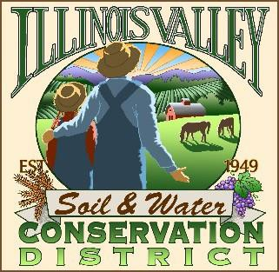
Illinois Valley Soil and Water Conservation District
331 E Cottage Park Dr Suite 1B - P.O. Box 352
Cave Junction, OR 97523 Phone: 541-592-3731

Monthly Board Meeting Agenda April 28,2022- SWCD Office/ZOOM

- 6:00 PM: Call to Order
- 6:15PM: Acceptance of Minutes
- 6:18PM: Acceptance of Financial Reports
- 6:20 PM: Old Business
  - Hiring update- Conservation Program Manager
  - White Ditch Scott Fein Deliverables
  - Volunteer Agreement- progress
  - Water Quality Monitoring
- 6:50 PM: New Business

- 7:00 PM: Staff and Partnering Agency Reports
  - Kevin’s report
  - Cheryl’s report
  - Arlyse’s Report

- 7:10 Public comments

- 7:15 PM: Adjourn

