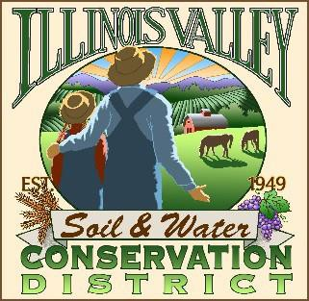

**Illinois Valley Soil and Water Conservation District**

331 E Cottage Park Dr Suite 1 - P.O. Box 352

Cave Junction, OR 97523 Phone: 541-592-3731

**Monthly Meeting Agenda June 26, 2025- *IVSWCD Office/ZOOM***

IVSWCD is inviting you to a scheduled Zoom meeting.

Topic: Illinois Valley Soil & Water Conservation District Meeting

Time: July 24, 2025 - 6:00 pm Join Zoom Meeting:

<https://us06web.zoom.us/j/95435099861?pwd=UXNsUEgyT200Ym9ZUVhEa1UvbnFUdz09>

***Meeting ID: 954 3509 9861***

***Passcode: Conserve***

1. **6:00 PM: Call to Order**
2. **6:01 PM: Acceptance of Minutes**
3. **6:05 PM: Acceptance of Financial Reports**
4. **6:10 PM: Old Business**
   1. **Thompson Creek plan**
5. **6:15 PM: New Business**
   1. **Expansion of employee roles**

**6:30 PM: Staff and Partnering Agency Reports**

* 1. **John’s report**
  2. **Arlyse’s Report**
  3. **Partnering Agency Reports**

1. **7:00 Public comments**
2. **7:15 Adjournment**