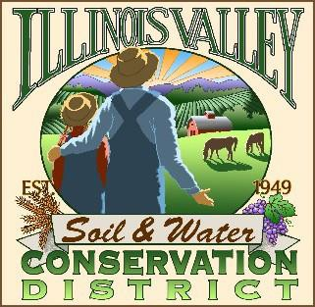
Illinois Valley Soil and Water Conservation District
331 E Cottage Park Dr Suite 1B - P.O. Box 352
Cave Junction, OR 97523 Phone: 541-592-3731

Monthly Board Meeting Agenda February 23, 2023- SWCD Office/ZOOM

- 6:00 PM: Call to Order
- 6:05 PM: Acceptance of Minutes
- 6:15 PM: Acceptance of Financial Reports
- 6:20 PM: Old Business
  - White Ditch Update
  - Budget Committee Report (action)
  - Feedback deadline for Director Eligibility (John)

- 6:45 PM: New Business
  - Coffee and Quail invitation (Cheryl)

- 7:00 PM: Staff and Partnering Agency Reports
  - John’s report
  - Cheryl’s report
  - Arlyse’s Report

- 7:20 PM Public comments

- 7:30 PM: Adjourn

