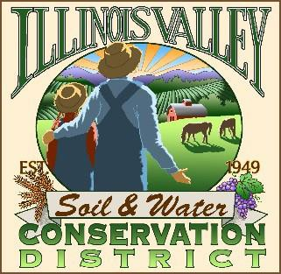

**Illinois Valley Soil and Water Conservation District**

331 E Cottage Park Dr Suite 1B - P.O. Box 352

Cave Junction, OR 97523 Phone: 541-592-3731

**Monthly Board Meeting Agenda July 25, 2024- *SWCD Office/ZOOM***

1. **6:00 PM: Call to Order**
2. **6:05 PM: Acceptance of Minutes**
3. **6:10 PM: Acceptance of Financial Reports**
4. **6:15 PM: Old Business**
   1. **AG Water Quality Monitoring Update**
   2. **Contracting With Two Rivers July 2024- June 2025**
5. **6:40 PM: New Business**
   1. **H.R. Committee Recommendation/WQ tech re-hire**
6. **7:00 PM: Staff and Partnering Agency Reports**
   1. **John’s report**
   2. **Arlyse’s Report**
   3. **Partnering Agency Reports**

* **IVWC**
* **ODA**
* **Two Rivers SWCD**

1. **7:20 PM Public comments**
2. **7:30 PM: Adjourn**