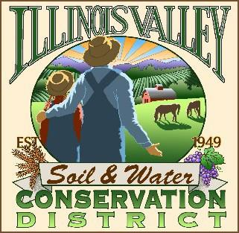

**Illinois Valley Soil and Water Conservation District**

331 E Cottage Park Dr Suite 1B - P.O. Box 352

Cave Junction, OR 97523 Phone: 541-592-3731

**Monthly Board Meeting Agenda May 23, 2024- *SWCD Office/ZOOM***

1. 6:00 PM: Call to Order
2. 6:05 PM: Acceptance of Minutes
3. 6:10 PM: Acceptance of Financial Reports
4. 6:15 PM: Old Business
   1. Water Quality Update Maelagh Baker
   2. Reminder- election materials available on ODA Website
   3. Planning for Hanby Block Party
   4. Committee Formation for 75th Anniversary Celebration
5. 6:40 PM: New Business
6. T>B>A>
7. 7:00 PM: Staff and Partnering Agency Reports
   1. John’s report
   2. Arlyse’s Report
   3. Partnering Agency Reports
8. 7:20 PM Public comments
9. 7:30 PM: Adjourn