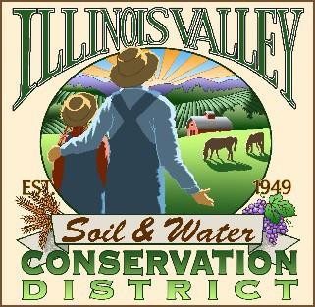
Illinois Valley Soil and Water Conservation District
331 E Cottage Park Dr Suite 1 - P.O. Box 352
Cave Junction, OR 97523 Phone: 541-592-3731

Monthly Meeting Agenda December 18, 2025- IVSWCD Office/ZOOM
Topic: Illinois Valley Soil & Water Conservation District Meeting
Time: December 18, 2025 - 6:00 pm
Join Zoom Meeting: IVSWCD is inviting you to a scheduled Zoom meeting.
Topic: Illinois Valley SWCD Monthly Meeting
Time: Dec. 18, 2025 06:00 PM
Join Zoom Meeting
https://us06web.zoom.us/j/83068803901?pwd=ndUiakpPGOA33OmTmbBvi82JDzzAPK.1
Meeting ID: 830 6880 3901
Passcode: 972185

- 6:00 PM: Call to Order
- 6:01 PM: Acceptance of Minutes
- 6:05 PM: Acceptance of Financial Reports
- 6:10 PM: Old Business
  - T.B.A.

- 6:15 PM: New Business
  - T.B.A.
6:20 PM: Staff and Partnering Agency Reports
  - John’s report
  - Arlyse’s Report
  - Partnering Agency Reports
- 6:25 Public comments
- 6:30 Adjournment- Christmas Party

