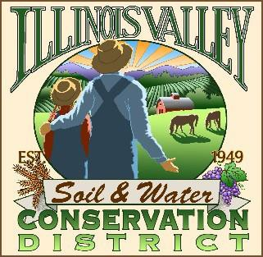

**Illinois Valley Soil and Water Conservation District**

331 E Cottage Park Dr Suite 1B - P.O. Box 352

Cave Junction, OR 97523 Phone: 541-592-3731

**Monthly Board Meeting Agenda September 26, 2024- *SWCD Office/ZOOM***

1. **6:00 PM: Call to Order**
2. **6:05 PM: Acceptance of Minutes**
3. **6:10 PM: Acceptance of Financial Reports**
4. **6:15 PM: Old Business**
   1. **AG Water Quality Monitoring Update**
   2. **Two River- Discussion w/ Eric Nusbaum and Lake County SWCD DM Justin Ferrell**
   3. **IVSWCD 75th Anniversary Planning Update**
   4. **Bio-Char Kiln Move Update**
   5. **District Manager Training Update**
5. **6:50 PM: New Business**
   1. **Re-set Annual Meeting**
   2. **Budget Committee Recommendations**
6. **7:10 PM: Staff and Partnering Agency Reports**
   1. **John’s report**
   2. **Arlyse’s Report**
   3. **Partnering Agency Reports**

* **IVWC**
* **ODA**
* **Two Rivers SWCD**

1. **7:25 PM Public comments**
2. **7:30 PM: Adjourn**