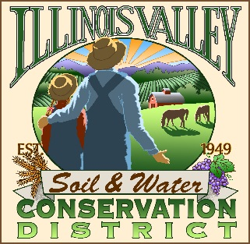 | Illinois Valley Soil and Water Conservation District  331 E Cottage Park Dr Suite 1B - P.O. Box 352  Cave Junction, OR 97523  Phone: 541-592-3731

Bi-Monthly Board Meeting Agenda

August 26, 2021- SWCD Conference Room/ZOOM

- 6:00 PM: Call to Order

- 6:05: Acceptance of Minutes

- 6:30 PM: Acceptance of Financial Reports
- 6:35 PM: Old Business
  - Water Quality Subcommittee- action item-tie in with WC
  - Farmer’s Market
  - Hiring committee report- Introduction of Community Organizer

- 6:55 PM: New Business
  - LAC action item
  - Resolution to hold annual meeting in December
  - MOA with NRCS
  - Advocacy Policy
  - Water Quality Monitoring

- 7:10 PM: Staff and Partnering Agency Reports
  - David Ferguson- NRCS report on local activity
  - Tracey’s report
  - Chris’ report
  - Arlyse’s Report

- 7:10 PM: Public Comments

- 7:15 PM: Adjourn
LAC- Local (water quality)Advisory Committee
MOA-Memorandum of Agreement
NRCS- Natural Resources Conservation Service

