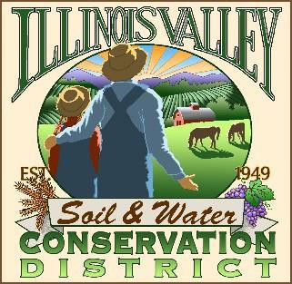
Illinois Valley Soil and Water Conservation District
331 E Cottage Park Dr Suite 1 - P.O. Box 352 Cave Junction, OR 97523 Phone: 541-592-3731

Monthly Meeting Agenda May 28, 2026 - IVSWCD Office/ZOOM
Topic: Illinois Valley Soil & Water Conservation District Meeting Time: May 28, 2026 - 6:00 pm
Join Zoom Meeting: IVSWCD is inviting you to a scheduled Zoom meeting. Topic: Illinois Valley SWCD Monthly Meeting
Time: May 28, 2026 6:00 PM
Join Zoom Meeting https://us06web.zoom.us/j/83068803901?pwd=ndUiakpPGOA33OmTmbBvi82JDzzAPK.1
Meeting ID: 830 6880 3901
Passcode: 972185

- 6:00 PM: Call to Order
- 6:01 PM: Acceptance of Minutes
- 6:05 PM: Acceptance of Financial Reports - Unavailable
- 6:10 PM: Old Business
  - Hiring Update

- 6:15 PM: New Business
  - Place-Based Planning Presentation – Jill Smedstad and Craig Harper
  - Acknowledgement of Arlyse DeLoyola’s Service to the Josephine County SWCDs and Illinois Valley Watershed Council – John Bellville and Kevin O’Brien
7:00 PM: Staff and Partnering Agency Reports
- John’s report
- Partnering Agency Reports
- 7:30 PM Public comments

